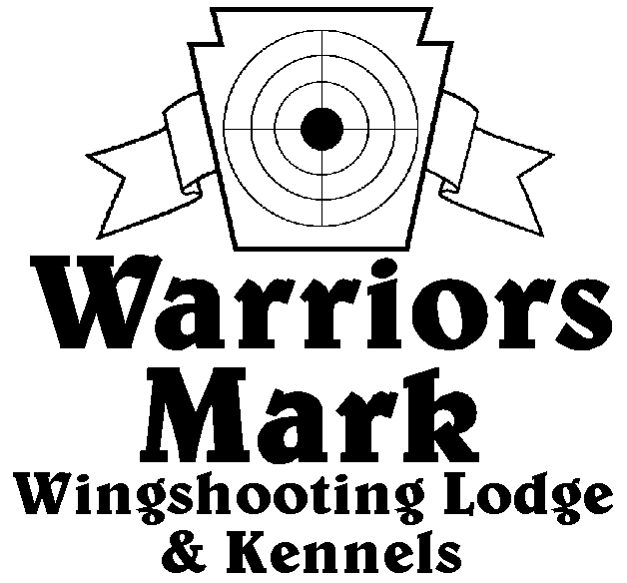
RESULTS - The 2024 Chukar Challenge was held at Warriors Mark Wingshooting Lodge on March 16th. We want to thank all those who participated in the event as well as the many spectators who came to watch. The following are the results of each division and class represented at this event.
548 Hunt Club Dr. Ginter, PA 16651
814-378-8380 www.warriorsmark.com

HUNTER NAME(S) DOG NAME BREED SCORE

Single Pointing
*Mike Gray Blitz GSP 341
*Tim Heady Ranger Brit 330
*Ryan Dehaas Gus GSP 318
James Boone Wiskey GSP 303
Mike Gray Jake P 301
Marshall Gregory Bean GSP 295
Mark Breedlove Bella Griffon 293
Rich Matthies Timber V 271
Scott Baker Gunner GSP 267
Mike Gray Rip GSP 260
Tim Heady Mavrick Brit 250
Tim Heady Mavrick Brit 225
Kenny Mountanaro Jack Griffon 205
Rich Mathias Tessla V 205
Dave Unger Merlot GSP 195
Dave Unger Merlot GSP 195
Chuck Hanley Wilbrow Griffon 175

Single Flushing
*Matt Brooker Gouse Lab 325
*Jeff Holtz Anna ESS 309
* Don Haingray Maizey Lab 306
Steve Dunsmore Dixie ESS 292
Nick McGary Porter Lab 280
Matt Brooker Gouse Lab 265
Jeff Nelson Gambit ESS 265
Andrew McGary Jubal Lab 260
Scott McGary Remington Lab 255
Jeff Nelson Jubilee ESS 245
Steve Smith Ladd ESS 235
Steve Smith Zane ESS 225
Ken Wilson Roamer ESS 175

Team Flushing
*Nick Gray Porter Lab 447
Boone Gray
*Dan Haingray Maizey Lab 421 Gary Jones
Bill StClair True Lab 370
Gary Bowman
Bill StClair True Lab 369
Gary Bowman
Jeff Holtz Annie ESS 350
James Holtz
Scott McGary Remington Lab 340
Boone McGary
Andrew McGary Jubal Lab 282
Boone McGary
Preston Bowers Dux Lab 195
Kaleb Brown

*Trophy Winners

