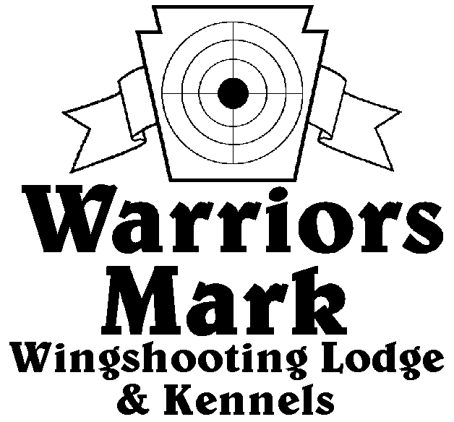
RESULTS - The 2022 Chukar Challenge was held at Warriors Mark Wingshooting Lodge on March 19th. We want to thank all those who participated in the event as well as the many spectators who came to watch. The following are the results of each division and class represented at this event.
548 Hunt Club Dr. Ginter, PA 16651
814-378-8380 www.warriorsmark.com

HUNTER NAME(S) DOG NAME BREED SCORE

Puppy Pointing
*Mike Gray Tillie GSP 207
*Mike Gray Rip GSP 194
Mike Gray Klaus WHP 189
Tammy Koleszer Rain Britt 182
Ron Guidas Granger P 141
Fred Wagner John Wesley ES 120

Single Pointing
*Bobby Little Duke Brit 343
*Bobby Little Duke Brit 336
*Jim Hughes Blitzen GSP 326
Dan Blough Ruger GSP 324
Tim Heady Ranger Brit 323
Mike Gray Blitz GSP 318
Jason Dini Finnegan Brit 315
Aaron Cider Archie WHP 311
Jim Hughes Axel GSP 300
Craig Loreman Storm WHP 300
Dave Michalek Gator P 278
Dave Michalek Tonka P 275
Dave Unger Merlot GSP 268
Dan Blough Tessa GSP 262
Dave Unger Merlot GSP 246
Mike Gray Rip GSP 184

Team Pointing
*Dave Michalek Gator P 368
Ron Guidas
Aaron Cider Archie WHP 357
Paul Smith

Single Flushing
*Ron Guidas Robyn ESS 349
*Scott MaGary Remington Lab 317
*Steve Smith Zane ESS 317
Jeff Holtz Annie ESS 316
Nicholas McGary Portler Lab 294
Steve Smith Ladd ESS 260
Robert Zeh Sunny ESS 245
Andrew McGary Jubal Lab 245
Tim Rohrer Elroy Lab 215
Tim Rohrer Emmy Lab 210

Team Flushing
*Ron Guidas Robyn ESS 448
Dave Michalek
*Robert Zeh Sunny ESS 431
Ron Guidas
Nicholas McGray Partter Lab 421
Boone McGary
Andrew McGary Jabel Lab 414
Boone McGary
Jeff Holtz Annie ESS 360
James Holtz
Scott McGary Remington Lab 355
Andrew McGary

*Trophy Winners

