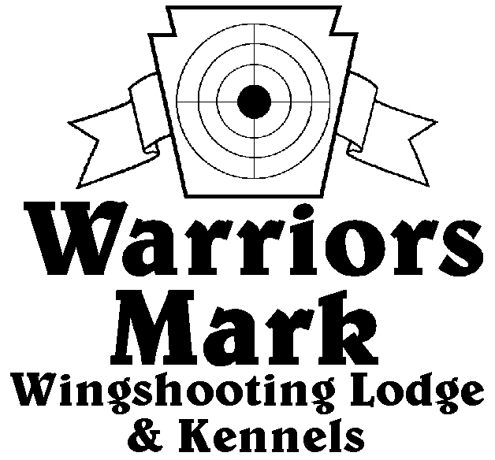
RESULTS - The 2021 Chukar Challenge was held at Warriors Mark Wingshooting Lodge on March 20th and 21st. We want to thank all those who participated in the event as well as the many spectators who came to watch. The following are the results of each division and class represented at this event.
548 Hunt Club Dr. Ginter, PA 16651
814-378-8380 www.warriorsmark.com

HUNTER NAME(S) DOG NAME BREED SCORE

Puppy Pointing
*Matt Chapman Sage GSP 217
*Ben Misko Martha English Setter 215
Matt Chapman Sage GSP 197
Bobby Landman Gunner GSP 195
Matt Myers Kimber GSP 179
Mike Prohaska Forest P 172
Bobby Landman Penny GSP 139
Ryan Hoover Tillie IB 118

Single Pointing
*Randy Hilligus Trooper P 331
*Matt Myers Jack GSP 329
*Randy Hilligus Holler P 322
Jim Hughs Axel GSP 316
Matt Chapman Dice GSP 313
Matt Chapman Penny GSP 311
Mike Prohaska Dan P 303
Matt Myers Jack GSP 295
Dave Michalek Tonka P 271
Tom Gustouch Chap LS 263
Aaron Cidor Archie GR 275
Bobby Lendman Penny GSP 270
Charles Flashing Chick ES 260
Dave Michalek Gater P 260
Dave Unger Merlot GSP 259
Bobby Landman Gunner GSP 246
Mitch Chirdon Ellie GSP 245
Dave Michalek Nitro P 236
Garrett Thomas Murphy P 210
Dave Unger Merlot GSP 180

Team Pointing
*Mike Prohoska Dan P 444
Luke Prohoska
*Charles Fashing Chick ES 431
Ryan Miller
Dave Michalek Gator P 431
Ron Guidas
Aaron Cidor Archie G 382
Kyle Brown
Garett Thomas Murphy IB 328
Joe Bender
Puppy Flushing
*Ken Chapman Lucy Lab 227
Bob Long Sawyer Lab 217
Rich Frantz Zeek GR 186

Single Flushing
*Dave Miller Taz Lab 348
*Dave Miller Bell Lab 346
*Ken Chapman Lucy Lab 335 Charles Flashing Choc Lab 334
Jeff Holtz Annie ESS 331
Albert Ricci Remi Lab 325
Jeff Thomas Dexter AC 321
Rich Frantz Bo Lab 321
Rich Frontz Millie GR 313
Matt Broker Goose Lab 306
Ron Guidas Robin ESS 299
Keith Myers Gauge Lab 296
Preston Bowers Dux Lab 287
Jeff Murphy Cash Lab 266
Bob Zeh Sunny ESS 263
Wally Simpkins Resputin Lab 242
Mark O’Donnell Hank Lab 195
Wally Simpkins Resputin Lab 190

Team Flushing
*Dave Miller Bell Lab 470
Ryan Miller
*Charles Flashing Choc Lab 463
Ryan Miller
*Keith Myers Gauge Lab 457
Matt Myers
Dave Miller Taz Lab 430
Ryan Miller
Matt Broker Goose Lab 439
Tom Carol
Jeff Holtz Anne ESS 420
James Holtz
Rich Frontz Bo Lab 411
Ken Chapman
Bob Zeh Sunny ESS 388
Ron Guidas
Ron Guidas Robin ESS 370
Dave Michalek
Jeff Murphy Cash Lab 318
Jake Murphy
Preston Bower Dux Lab 300
Colby Smith

*Trophy Winners

