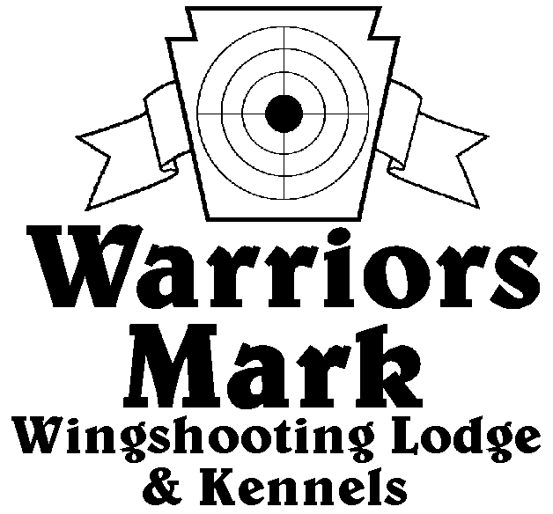
RESULTS - The 2020 Chukar Challenge Hunt was held at Warriors Mark Wingshooting Lodge. We want to thank all those who participated in the hunt as well as the many spectators who came to watch. The following are the results of each division and class represented at this hunt.
548 Hunt Club Dr. Ginter, PA 16651
814-378-8380 www.warriorsmark.com

HUNTER NAME(S) DOG NAME BREED SCORE

Single Pointing
*Mike Prohaska Dan P 311
*Mitch Chidron Ellie GSP 299
*Jim Hughes Axel GSP 284
Charles Fashing Chic ES 260
David Unger Merlot GSP 255
David Unger Merlot GSP 222
George Bills Bo P 219
George Bills Max ES 205
George Bills Bo P 200
Dallas Brird Smoke GSP 196
Frank Unger Bella GSP 194
George Bills Max P 147

Team Pointing
*Charles Fashing/Ryan Miller Chic ES 431
Mike Prohaska/Luke Prohaska Dan P 428

Puppy Flushing
*Dave Miller Belle Lab 221
Jeff Holtz Annie ESS 216

Single Flushing
*Dave Miller Taz Lab 342
*Dave Miller Belle Lab 341 T6.15
*Steve Smith Exxie ESS 341 T6.17
Steve Smith Gunner ESS 298
John Zlater Kenai Lab 287
Charles Fashing Choc Lab 220
Dallas Baird Hope Lab 205

Team Flushing
*Dave Miller/Ryan Miller Belle Lab 471
*Charles Fashing/Ryan Miller Choc Lab 457
*Dave Miller/Ryan Miller Taz Lab 441
Gary Laskowsky/Craig Ohs Ghost Lab 411
Craig Ohs/Gary Laskowsky Buck Lab 399 S 10
Doug Krause/Jared Neeper Finn ESS 399 S 12
Sawyer Krause/Robbie Krause Fiona ESS 250

