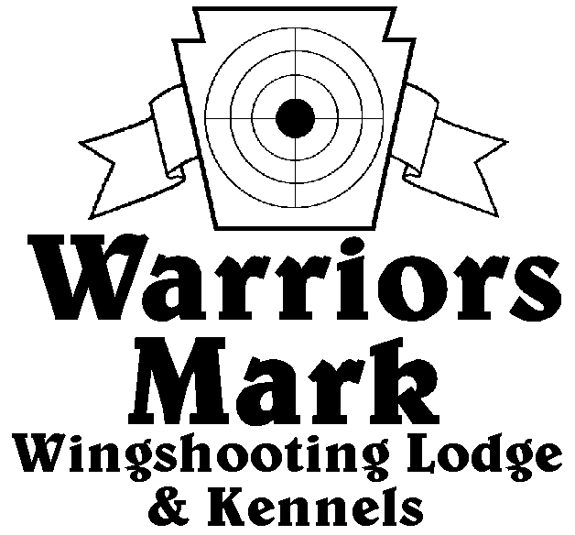
RESULTS - The 2019 Chukar Challenge was held at Warriors Mark Wingshooting Lodge. We want to thank all those who participated in the event as well as the many spectators who came to watch. The following are the results of each division and class represented at this event.
548 Hunt Club Dr. Ginter, PA 16651
814-378-8380 www.warriorsmark.com

HUNTER NAME(S) DOG NAME BREED SCORE

Puppy Pointing
Eric Scott Jutta DD 137

Single Pointing
*Jim Hughs Axel GSP 327
*Terry Beck Sophie GSP 321
*Charles Fashing Chic ES 318
Dan Blough Ruger GSP 317
Nick Ehart Sigg DD 282
Dallas Baird Smoke GSP 278
Terry Beck Sophie GSP 274
Dave Unger Merlot GSP 257
Dan Blough Tess GSP 227
Frank Unger Bella GSP 214
Nick Ehart River DD 190
Tim Payonk Bryar ES 180
Dave Unger Gizmo GSP 117

Team Pointing
*Taylor McKnight / Josh McKnight Winston GSP 453
*Matt Bumbera / Mike Bumbera Ryder GSP 431
Mike Prohaska / Robert Newhouse Dan EP 419
Charles Fashing / Dave Miller Chic ES 413
Matt Bumbera / Mike Bumbera Ryder GSP 377
Todd Hoffman / Matt Brown Mez ES 363
Kenny Chapman / Rich Frontz Jackson EP 325
Bill Brady / Isaac Brady Scarlet Brit 250

Puppy Flushing
*Matt Brooker Goose Lab 209
Rich Frantz Millie GR 208
Ted Brenneman Nittany ESS 198
Roxane Newton Ganzer CBR 165
Mike Fleck Ivy Lab 120

Single Flushing
*Zane Carns Emma Lab 348
*Dave Miller Taz Lab 334
*Charlies Fashing Choc Lab 331
Dave Miller Rumble Lab 320
Keith Myers Gauge Lab 308
Jim Hovey Maddi Lab 316
Del Monoskey Sam ESS 317
Charlie Frantz Reese Lab 281
Steve Smith Gunner ESS 270
Jeff Thomas Kota AC 268
Steve Smith Exxie ESS 260
Dallas Baird Hope Lab 230
George Monoskey Levi ESS 230
Jeff Thomas Dexter AC 195
Mike Newton Ganzer CBR 180

Team Flushing
*Dave Miller / Charles Fashing Taz Lab 461
*Dave Miller / Charles Fashing Rumble Lab 433
*Greg Schulttes / Jim Bennett Slick Lab 424
Zane Carns / Ed Carns Emma Lab 409
Rich Frontz / Kenny Chapman Reese Lab 404
George Monoskey/ Del Monoskey Levi ESS 394
Keith Myers / Charlie Frantz Gauge Lab 371
Charles Fashing / Dave Miller Choc Lab 365
Jim Bennett / Greg Schulttis Willow Lab 355
Del Monoskey/ George Monoskey Sam ESS 350
Jim Bennett / Greg Schultis Colt Lab 315

*Trophy Winners

