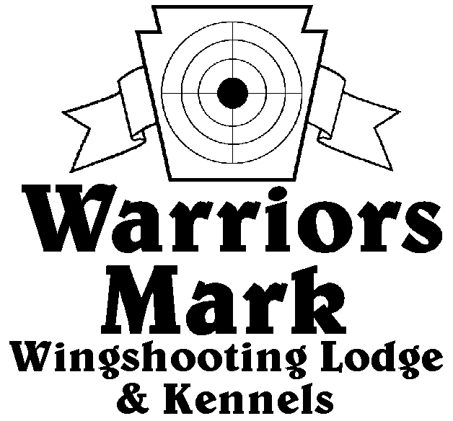
RESULTS - The 2018 Chukar Challenge was held at Warriors Mark Wingshooting Lodge. We want to thank all those who participated in the event as well as the many spectators who came to watch. The following are the results of each division and class represented at this event.
548 Hunt Club Dr. Ginter, PA 16651
814-378-8380 www.warriorsmark.com

HUNTER NAME(S) DOG NAME BREED SCORE

Puppy Pointing
*Jim Hughes Axel German Shorthaired P. 226
Brad Minnick Duck Brittany 211
Tom Kozlowski Winston German Shorthaired P. 60

Single Pointing
*Brad Minnick Doc Pointer 341
*Brad Minnick Rio Pointer 334
*Brad Minnick Snap Pointer 323
Dan Blough Rugger German Shorthaired P. 322
Charles Fashing Chic English Setter 317
Mike Gray Jake Pointer 314
Dan Blough Tessa German Shorthaired P. 312
Bob Johnson Kate Pointer 242
Mathew Bumbera Ryder German Shorthaired P. 205
David Unger Gizmo German Shorthaired P. 202
Dallas Baird Smoke Pointer 185
Tim Poyonk Bryer English Setter 200
David Unger Merlot German Shorthaired P. 150

Team Pointing
*Brad Minnick / Jordan Minnick Rio Pointer 425
*Charles Fashing / Dave Miller Chic English Setter 378
*Mitchell Blake / Mick Blake Moxie English Setter 355
Brad Minnick / Jordan Minnick Doc Pointer 300
Shawn Bernecky / Bob Antes Daphne Pointer 275
Shawn Bernecky / Bob Antes Daphne Pointer 269

Single Flushing
*Dave Miller Rumble Labrador Ret. 341
*Charles Fashing Choc Labrador Ret. 339
*Dave Miller Taz Labrador Ret. 339
Dave Miller Rayne Labrador Ret. 338
George Monoskey Levi English Springer Sp. 330
Jeff Thomas Dexter American Cocker Sp. 326
Chris Foust Cody Labrador Ret. 322
Del Monoskey Sampson English Springer Sp. 316
Barry Anderson Jazz Labrador Ret. 308
Jake Huff Mazie Golden Ret. 303
Mike Newton Switch Chesapeake Bay Ret. 303
Ryan Karlhiem Rett English Springer 302
Zane Carns Emma Labrador Ret. 302
Jeff Thomas Kota American Cocker Sp. 295
Steve Smith Gunner English Springer Sp. 225
Ron Guidas King English Springer Sp. 215
Barry Anderson Hawk Labrador Ret. 175
Steve Smith Exxie English Springer Sp. 166
Dallas Baird Hope Labrador Ret. 120

Team Flushing
*Dave Miller / Ryan Miller Rumble Labrador Ret. 470
*Dave Miller / Ryan Miller Taz Labrador Ret. 456
*Charles Fashing / Dave Miller Choc Labrador Ret. 455
Dave Miller / Ryan Miller Rayne Labrador Ret. 444
Zane Carns / Ed Carns Emma Labrador Ret. 441
Greg Schultheis / Ray May Slick Labrador Ret. 436
Del Monoskey / George Monoskey Samson English Springer Sp. 427
George Monoskey / Del Monoskey Levi English Springer Sp. 398
Jim Bennett / Ray May Rami Labrador Ret. 397
Charles Fashing / Ryan Miller Asher English Springer Sp. 345
Mark Schulties / Robert Yockomazch Cooper Labrador Ret. 230

*Trophy Winners

