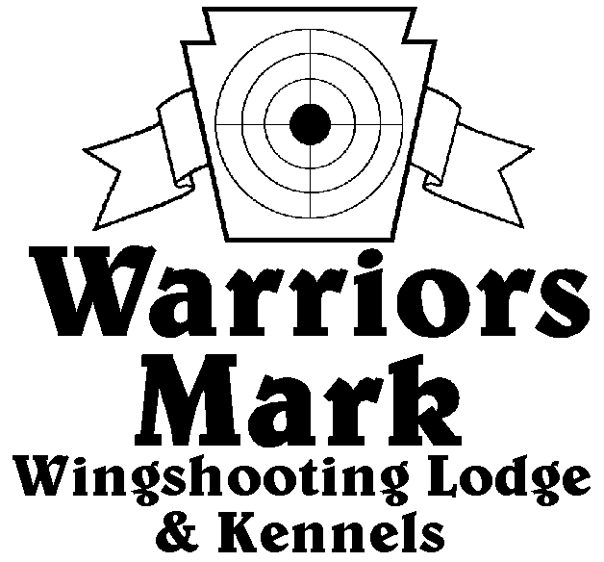
548 Hunt Club Dr. Ginter, PA 16651
814-378-8380 www.warriorsmark.com
RESULTS - The 2016 Chukar Challenge was held at Warriors Mark Wingshooting Lodge. We want to thank all those who participated in the event as well as the many spectators who came to watch. The following are the results of each division and class represented at this event. We would like to remind you of other events coming up: Dave Hollingshead Fall Kick Off September 17, 2016 PA State Open Pheasant Championship to be held October 15 & 16, 2016, and the 2017 Chukar Challenge/Hunting Dog Championship already scheduled for March18 & 19 2017.
Puppy Pointing
NAME DOG BREED SCORE
*Mitch Chirden Ellie GSP 224
*Gene Showers Coral P 192
Seth Dellinger River GSP 189
Brad Minnick Rio P 184
Gene Showers Brandi GSP 176
Gene Showers Cleo P 162
A.J. Rudy Bo P 155
Brad Minnick Snap P 148
Bob Johnson Kate P 135
Keith Risner Gray Rider ES 100
Bob Johnson Kate P 90

Single Pointing
NAME DOG BREED SCORE
*Beck Terry Sophia GSP 333
*Keith Risner Northern Passage ES 327
*Brad Minnick Trigger ES 322
Keith Risner Bella ES 313
Chuck Fashing Chic ES 307
Kevin Keisel Lyra ES 306
Bob Mathews Jagger GSP 299
Terry Beck Sophia GSP 290
Bob Matthews Jagger GSP 289
Gene Showers Beau P 289
Kevin Keisel Chaos ES 270
Brad Minnick Doc P 269
Terry Beck Max GSP 260
Clayton Neil Ranger ES 260
Keith Risner Northern Passage ES 260
Bob Mathews Dano ES 230
Brad Botteicher Oden DD 190
Todd Hoffman Quay B 185
Dan McGlynn Buddy GSP 185
Clayton Neal Ranger ES 175
Todd Hoffman Mez ES 120

Team Pointing
NAME PARTNER DOG BREED SCORE
*Chuck Fashing Kevin Keisel Chic ES 440
*Bob Mathews Keith Risner Jagger ES 413
*Kevin Keisel Chuck Fashing Chaos ES 406
Keith Risner Clayton Neil Northern Passage ES 377
Bob Matthews Keith Resner Dano ES 360
Chad Reid Travis Long Katnis GSP 330
Keith Risner Clayton Neil Texas Ranger ES 315

Puppy Flushing
NAME DOG BREED SCORE
*Rick Novella Casey Lab 207

Single Flushing
NAME DOG BREED SCORE
*George Monoskey Levi ESS 338
*Chuck Fashing Choc Lab 333
*Steve Smith Exxie ESS 322
Deana Keisel Serius Lab 303
Delbert Monoskey Sampson ESS 302
Mike Ott Drake Lab 270
Mike Newton Switch CBR 271
Wallace Simpkins Beaudaious Lab 249
Zane Carns Emma Lab 245
Kevin Keisel Rigel Lab 240
Dusty Derr Tripp Lab 225
Wallace Simpkins Beaudaious Lab 220
Bob Long Ozzy Lab 210
Steve Smith Chase ESS 125

Team Flushing
NAME PARTNER DOG BREED SCORE
*Ray May Greg Shultis K Lab 436
*Dusty Derr Jeff Farver Tripp Lab 422
*Del Monoskey George Monoskey Sampson ESS 415
Greg Schultis Jim Bennett Nicki Lab 305
Kevin Keisel Chuck Fashing Choc Lab 360
George Monoskey Del Monoskey Levi ESS 345
Jim Bennett Ray May Remi Lab 320
Zane Carns Ed Carns Emma Lab 320
Jim Bennett Ray May Jock Lab 275

*Trophy Winners

