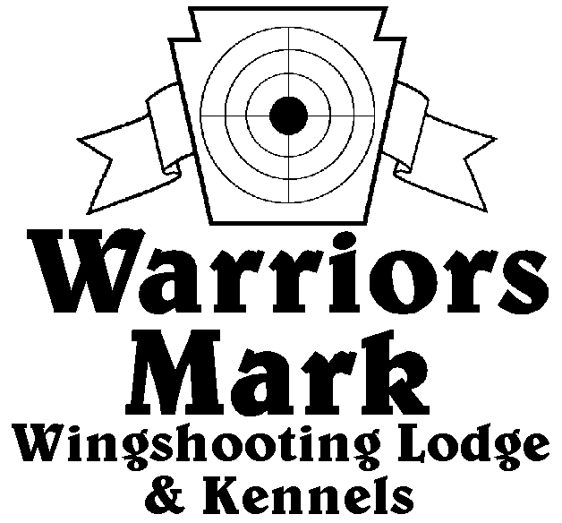
548 Hunt Club Dr. Ginter, PA 16651
814-378-8380 www.warriorsmark.com
RESULTS - The 2014 Chukar Challenge was held at Warriors Mark Wingshooting Lodge. We want to thank all those who participated in the event as well as the many spectators who came to watch. The following are the results of each division and class represented at this event. We would like to remind you of other events coming up: Dave Hollingshead Fall Kick Off September 20, 2014 PA State Open Pheasant Championship to be held October 18 & 19, 2014, and the 2015 Chukar Challenge/Hunting Dog Championship already scheduled for March 14 &15, 2014.
Puppy Pointing
NAME DOG BREED SCORE
*Keith Risner Dano Pointer 186
*Talon Landreth Shadow GSP 183
Peter Marks Trajan V 155
Rob Johnston Max Britt 130

Single Pointing
NAME DOG BREED SCORE
*Keith Risner Northern Passage ES 334
*Roy Yockey Soul GSP 330
*Mike Gray Jake P 311
Damon Kanabe Archer GSP 304
Todd Hoffman Mez ES 303
Todd Hoffman Quay Britt 298
Roy Yockey Sassy GSP 272
Keith Risner Rough Country ES 265
Keith Risner Bella ES 260
Gene Showers Tropper GSP 245
Bill Brady Scarlet Britt 223
Sean Bostic Jake P 220
Roy Yockey Mickey GSP 210
Dan McGlynn Buddy GSP 100

Team Pointing
NAME PARTNER DOG BREED SCORE
*Dan McGlynn Corey Natcher Buddy GSP 400
*Keith Risner Dan Buscher Bella ES 390
*Keith Risner DanBuscher Rough Country ES 386
Damon Knabe Curt Tucok Archer GSP 351
Todd Hoffman Dusty Derr Quay Britt 310

Puppy Flushing
NAME DOG BREED SCORE
*Del Monoskey Sampson ESS 209
*Dusty Derr Tripp Lab 205
Jimmy Foys Piper Lab 194
Andrew Foys Piper Lab 115

Single Flushing
NAME DOG BREED SCORE
*Jeff Thomas Cletus AC 328
*George Monoskey Levi ESS 324
*Mike Ott Drake Lab 318
Jeff Thomas Kota AC 313
Brad Batteicher Cole Lab 295
Pete Marks Einstien Lab 275
Zane Carns Emma Lab 255
Jim Hovey Maddi Lab 215
Wally Simpkins Beaudious Lab 120
Wallace Simpkins Beaudious Lab 95
Team Flushing
NAME PARTNER DOG BREED SCORE
*George Monoskey Del Monoskey Lilly ESS 448
*Zane Carns Ed Carns Emma Lab 425
*Greg Schultheis Ray May Max Lab 421
Jim Bennett Greg Schulteis Jock Lab 355
Jim Bennett Ray May Remi Lab 245
Ray May Greg Schultheis K Lab 315
*Trophy Winners

