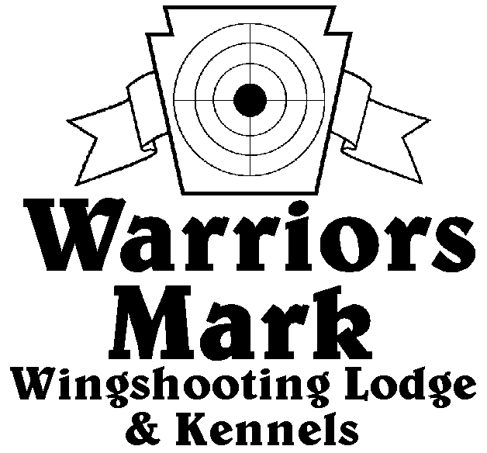
548 Hunt Club Dr. Ginter, PA 16651
814-378-8380 www.warriorsmark.com
RESULTS - The 2012 Chukar Challenge was held at Warriors Mark Wingshooting Lodge. We want to thank all those who participated in the event as well as the many spectators who came to watch. The following are the results of each division and class represented at this event. We would like to remind you of other events coming up: PA State Open Pheasant Championship to be held October 13 & 14, 2012, and the 2013 Chukar Challenge/Hunting Dog Championship already scheduled for March 9 & 10, 2013.
Puppy Pointing
NAME DOG BREED SCORE
*Brad Minnick Patch Pointer 215
*Roy Yockey Soul GSP 212
Gene Showers Trooper GSP 211
Charles Tabb Trigger GSP 208
William Miller Holly DD 198
Mike Rizzuto Athena ES 175
Joe Cole Emma GSP 168
Roy Yockey Hart GSP 150
Matt Gardner Bella GSP 125
Bob Gaffron Sophie ES 115
Joe Cole Emma GSP 105
Andy Thompson Ruger GSP 95
Jason Bloom Cooper GSP 75
Single Pointing
NAME DOG BREED SCORE
*Brad Minnick Snap Pointer 337
*Brad Minnick Storm GSP 335
*Brad Minnick Trigger ES 322
Kyle Baumgardner Dergo DD 320
Roy Yockey Hart GSP 240
William Miller Kassie DD 212

Team Pointing
NAME PARTNER DOG BREED SCORE
*Don Fix Eric Monhan Bella GSP 437
*Todd Hoffman Dusty Derr Quay Brit 393
*Tim Gardner Matt Gardner Bella GSP 360
Dusty Derr Jesse Moats Quay Brit 338
Todd Hoffman Jesse Moats Quay Brit 290
Puppy Flushing
NAME DOG BREED SCORE
*George Monoskey Levi ESS 219
Single Flushing
NAME DOG BREED SCORE
*Kevin Keisel Shiva Lab 349
*Mike Baronio Hunter Lab 346
*Kevin Keisel Rigel Lab 341
Jeff Thomas Cletus AC 335
Steve Smith Chase ESS 328
Kevin Keisel Sirius Lab 327
Mike Baronio Tyson Lab 327
Mike Baronio Tyson Lab 324
Jim Hovey Maddi Lab 322
Matt Harris Liberty Lab 321
George Monoskey Lilly ESS 319
Matt Brooker Blade Lab 314
Mike Baronio Hunter Lab 284
Frank Gabriel Scooter Lab 265
Bob Long Ozzy Lab 250
Jeff Thomas Kota AC 240
Team Flushing
NAME PARTNER DOG BREED SCORE
*George Monoskey Delbert Monoskey Lilly ESS 447
*Bob Long Chip Good Ozzy Lab 365 Tie
*Greg Schultheis Ray May Max Lab 365 Tie
Ken Rybarczyk Frank Gabriel Candi Lab 355
Frank Gabriel Ken Rydarczyk Scooter Lab 325
Matt Harris Frank Gaydosh Liberty Lab 315
*Trophy Winners

