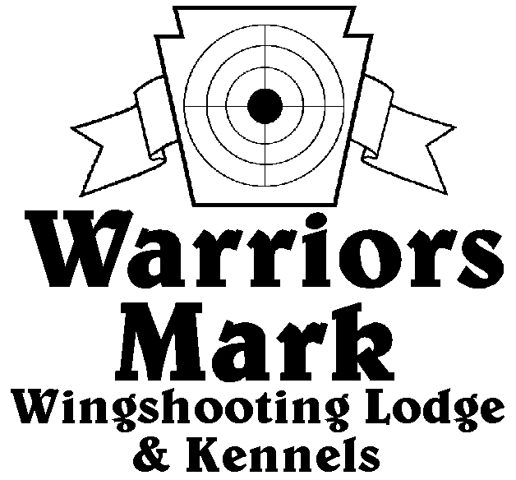

548 Hunt Club Dr. Ginter, PA 16651
814-378-8380 www.warriorsmark.com
RESULTS - The 2011 Chukar Challenge was held at Warriors Mark Wingshooting Lodge. We want to thank all those who participated in the event as well as the many spectators who came to watch. The following are the results of each division and class represented at this event. We would like to remind you of three other events coming up: Lion Country Birddog Days September, 2011, PA State Open Pheasant Championship to be held October 15 & 16, 2011, and the 2012 Chukar Challenge/Hunting Dog Championship already scheduled for March 10 & 11, 2010.
Puppy Pointing
NAME DOG BREED SCORE
*Brad Minnick Storm German Shorthair Pointer 216
*Brad Holdren Tala English Setter 180
Chris Miller Ike English Setter 162
Todd Hoffman Quay Brittany 145
Todd Hoffman Quay Brittany 145

Single Pointing
NAME DOG BREED SCORE
*Brad Minnick Snap Pointer 329
*Brad Minnick Trigger English Setter 324
*Don Calhoun Jade German Shorthair Pointer 310
Don Fix Rose German Shorthair Pointer 304
Don George Buddy German Shorthair Pointer 301
Jim Hughes Pepper German Shorthair Pointer 295
Don Calhoun Jade German Shorthair Pointer 285
Mark Walter Dok German Shorthair Pointer 277
Jim Lysle Holly Pointer 261
Garrett Thomas Clint Weimaraner 260
Tim Palmer Snoop German Shorthair Pointer 245
Lisa Calhoun Mandy German Shorthair Pointer 245
Mark Minnick Lizzy Brittany 222
Mark Minnick Peanut Brittany 220
Dallas Baird Lewk German Shorthair Pointer 200
Shawn Garris Amos German Shorthair Pointer 155

Team Pointing
NAME PARTNER DOG BREED SCORE
*Don George Hayden George Buddy German Shorthair Pointer 447
*Garret Thomas Matt Holtz Clint Weimaraner 428
*Todd Hoffman Jesse Moats Jax English Setter 420

Puppy Flushing
NAME DOG BREED SCORE
*Jim Hovey Maddi Labrador Retriever 210
*Jeff Thomas Kota American Cocker 209

Single Flushing
NAME DOG BREED SCORE
*Steve Smith Chase E. Springer Spaniel 337
*Tom Carrol Mazey Labrador Retriever 333
*Mike Baronio Hunter Labrador Retriever 330
Mike Baronio Tyson Labrador Retriever 331
Jake Huff Molly Golden Retriever 328
Bob Long Ozzy Labrador Retriever 324
Rob Smith Dakota Labrador Retriever 323
John Dunn Broghin E. Springer Spaniel 318
Keith Thomas Drake Labrador Retriever 318
Jeff Thomas Autum American Cocker 318
Barry Anderson Jazz Labrador Retriever 317
Jeff Thomas Cletus American Cocker 314
Bob Long Ozzy Labrador Retriever 314
Matt Brooker Blade Labrador Retriever 310
Barry Anderson Luke Labrador Retriever 303
Barry Anderson Ruby Labrador Retriever 298
Jamie Klark Nugent Labrador Retriever 283
Neil Thomas Gage Labrador Retriever 247
Chris Faust Scout Labrador Retriever 140

Team Flushing
NAME PARTNER DOG BREED SCORE
*Bob Long Chip Good Ozzy Labrador Retriever 420
*Neil Thomas Keith Thomas Gage Labrador Retriever 390
*Keith Thomas Neil Thomas Drake Labrador Retriever 300

*Trophy Winners

