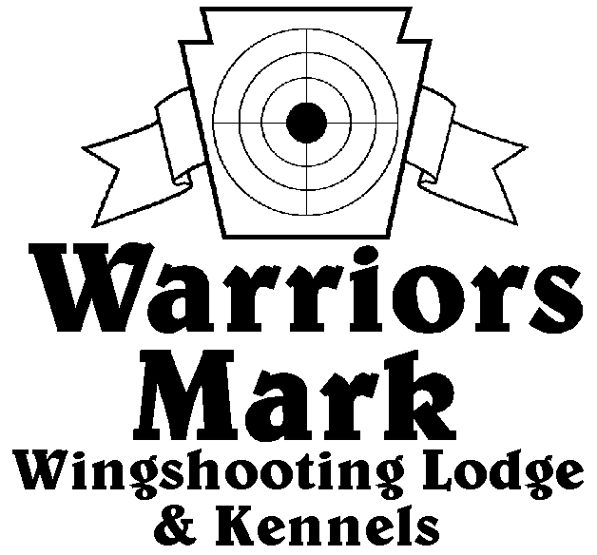

548 Hunt Club Dr. Ginter, PA 16651
814-378-8380 www.warriorsmark.com
RESULTS - The 2010 Chukar Challenge was held at Warriors Mark Wingshooting Lodge. We want to thank all those who participated in the event as well as the many spectators who came to watch even with the down pours of rain. The following are the results of each division and class represented at this event. We would like to remind you of three other events coming up: Lion Country Birddog Days September, 11 2010, PA State Open Pheasant Championship to be held October 23 & 24, 2010, and the 2010 Chukar Challenge/Hunting Dog Championship already scheduled for March 12 & 13, 2010.
Puppy Pointing
NAME DOG BREED SCORE
*#Don Fix Rose German Shorthair Pointer 174
*Brad Minnick Lilly German Shorthair Pointer 170
Nick Gates Alex English Setter 150
Tom Launer Buddy German Shorthair Pointer 130
#Mark Rozum Elvira Labrador Retriever 95

Single Pointing
NAME DOG BREED SCORE
*John Zalewski Alli German Shorthair Pointer 343
*John Zalewski Snap German Shorthair Pointer 341
*Brad Minnick Haley German Shorthair Pointer 326
Shawn Bernecky Darty Pointer 326
Brad Minnick Snap Pointer 322
Jim Hughes Pepper German Shorthair Pointer 321
John Zalewski Max German Shorthair Pointer 319
Shawn Garris Amos German Shorthair Pointer 315
Mike Luke Rose English Setter 312
Mark Minnick Hunter Brittany 299
Mark Minnick Zizzy Brittany 298
Shawn Bernecky Dyson Pointer 298
Gene Showers Cotton German Shorthair Pointer 291
#Rich VanNosdeln Deacon English Setter 290
Roy Hurd Heidi Brittany 289
Jim Hughes Pepper German Shorthair Pointer 273
Dallas Baird Luke German Shorthair Pointer 270
#Garret Thomas Clint Weimaraner 260
Nathan Green Deacon German Shorthair Pointer 238

Team Pointing
NAME PARTNER DOG BREED SCORE
*#Andy Walowen Joe Ihlenfeid Willy German Shorthair Pointer 441
*#Garret Thomas Kevin Smithmyer Clint Weimaraner 392
*Jim Houppert Joe Cox Gertie Weimaraner 346
Puppy Flushing
NAME DOG BREED SCORE
*Jamie Klark Nugent Labrador Retriever 218
*Tim McGarry Nox Labrador Retriever 213
Tim McGarry Nox Labrador Retriever 196
Ron Guidas Scout Springer Spaniel 184

Single Flushing
NAME DOG BREED SCORE
*Kevin Keisel Rigel Labrador Retriever 347
*Mike Baronio Tyson Labrador Retriever 346
*Kevin Keisel Aurora Labrador Retriever 344
David Miller Rayne Labrador Retriever 341
Rob Smith Dakota Labrador Retriever 340
#Jake Huff Molly Golden Retriever 339
Matt Brooker Blade Labrador Retriever 336
Tom Carroll Mozie Labrador Retriever 335
Bob Long Ozzy Labrador Retriever 334
Dave Miller Rumble Labrador Retriever 334
Jeff Thomas Autumn Am. Cocker Spaniel 333
Richard Smith Dyna Labrador Retriever 331
Mike Baronio Hunter Labrador Retriever 330
Jeff Thomas Cletus Am. Cocker Spaniel 329
#Barry Anderson Ruby Labrador Retriever 325
#Charles Squillante Roxy Springer Spaniel 325
Richard Smith Asa Labrador Retriever 323
Jim Squillante Summer Labrador Retriever 322
Denny Massa Thunder Labrador Retriever 301
John Zalewski Duke Labrador Retriever 270

Team Flushing
NAME PARTNER DOG BREED SCORE
*David Miller Kevin Keisel Rayne Labrador Retriever 475
*David Miller Kevin Keisel Rumble Labrador Retriever 470
*Kevin Keisel David Miller Rigel Labrador Retriever 468
#Jake Huff Chris Foust Molly Golden Retriever 460
#Bob Long Chip Good Ozzy Labrador Retriever 459
#Greg Schultheis Ray May Millie Labrador Retriever 453
Pete Rizzo Pete Rizzo Jr. Cody En. Cocker Spaniel 436

*Trophy Winners
#Option Pool Winners

