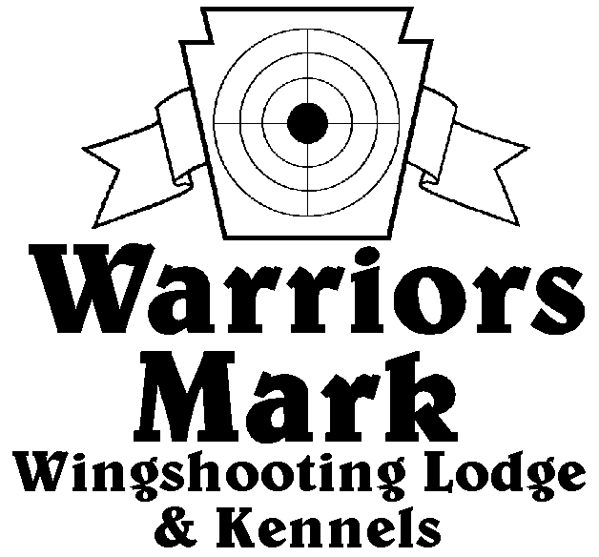
548 Hunt Club Dr. Ginter, PA 16651
814-378-8380 www.warriorsmark.com
RESULTS - The 2015 Chukar Challenge was held at Warriors Mark Wingshooting Lodge. We want to thank all those who participated in the event as well as the many spectators who came to watch. The following are the results of each division and class represented at this event. We would like to remind you of other events coming up: Dave Hollingshead Fall Kick Off September 26, 2015 PA State Open Pheasant Championship to be held October 24-25, 2015, and the 2016 Chukar Challenge/Hunting Dog Championship already scheduled for March 2016.
Puppy Pointing
Name DOG BREED SCORE
*Gene Showers Beau GSP 224
*Dan Buschur Sage ES 216
Chad Reid Katniss GSP 203
Bob Rairigh Rosco P 110
Chad Reid Katniss GSP 95

Single Pointing
NAME DOG BREED SCORE
*Kevin Keisel Chaos ES 336
*Kevin Keisel Lyra ES 332
*Gene Showers Trooper GSP 321
Todd Hoffman Quay Britt 311
Todd Hoffman Mez ES 309
Dan Buschur Sage ES 308
Diana Keisel Chaos ES 299
Chuck Fashing Chic P 296
Dan McGlynn Buddy GSP 295
Pete Marks Trajan VZ 250
David Plummer Kita P 224

Team Pointing
NAME PARTNER DOG BREED SCORE
*Chuck Fashing Kevin Keisel Chick P 455
*Kevin Keisel Gary G Lyra ES 422

Single Flushing
NAME DOG BREED SCORE
*Kevin Keisel Luna Lab 346
*Mike Newton Switch CBR 328
*Chuck Fashing Choc Lab 324
Barry Anderson Jazz Lab 320
Del Monoskey Sam ESS 317
Frank Gabriel Scooter Lab 298
Tom Matterer Kramer GR 297
Wally Sampkins Beaudeous Lab 277
Steve Smith Exie ESS 271
Zane Carns Emma Lab 269
Barry Anderson Jazz Lab 265
Mike Ott Drake Lab 260
Wally Simpkins Beaudeous Lab 240
Steve Smith Chase ESS 225
Todd Emigh Nite Lab 220T
Pete Marks Einstein Lab 220T
George Monoskey Lilly ESS 195
Frank Gabriel Scooter Lab 180
Team Flushing
NAME PARTNER DOG BREED SCORE
*Del Monoskey George Monoskey Sam ESS 441
*George Monoskey Del Monoskey Levi ESS 439
*Dusty Derr Todd Hoffman Tripp Lab 405
Dusty Derr Todd Hoffman Tripp Lab 374
Zane Carns Ed Carns Emma Lab 355 *Plaque Winners

