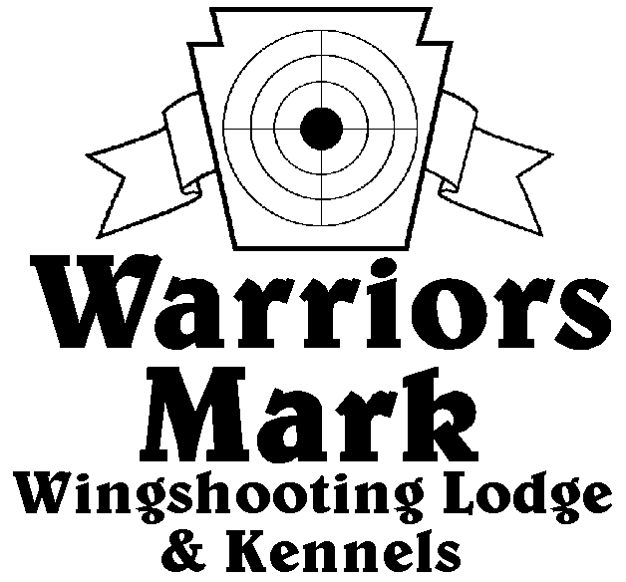
548 Hunt Club Dr. Ginter, PA 16651
814-378-8380 www.warriorsmark.com
RESULTS - The 2013 Chukar Challenge was held at Warriors Mark Wingshooting Lodge. We want to thank all those who participated in the event as well as the many spectators who came to watch. The following are the results of each division and class represented at this event. We would like to remind you of other events coming up: PA State Open Pheasant Championship to be held October19 & 20 , 2013, and the 2014 Chukar Challenge/Hunting Dog Championship already scheduled for March 9 & 10 , 2014.

Puppy Pointing

NAME DOG BREED SCORE
*John Wolfe Briggs GSP 174
*Mike Gray Jake Pointer 159
Todd Hoffman Mez ES 110
Stanly Reck Paxton ES 105
Mark Walter Murphy Pointer 55

Single Pointing

NAME DOG BREED SCORE
*Kevin Keisel Lyrs ES 333
*John Guzzi Rugger Brit 332
*Brad Minnick Trigger ES 324
Gene Showers Trooper GSP 323
Brad Minnick Snap Pointer 320
Mark Seifort Asa Brit 312
Tim Gardner Bella GSP 304
John Wolfe Briggs GSP 273
Frank Franci T-Bone Britt 272
Tim Gardner Bella GSP 265
Todd Hoffman Quay Brit 248
Nathan Kotansky Prarie GSP 240
Dan Richards Murph GSP 209
Kyle Baumgardner Dargo DD 205

Team Pointing

NAME PARTNER DOG BREED SCORE
*Nathan Kotansky Matt Gardner Prarie GSP 386
*Tim Gardner Matt Gardner Bella GSP 384
*Tim Gardner NathanKotapsky Bella GSP 384
Todd Hoffman Jeff Thomas Quay Brit 360

Puppy Flushing

NAME DOG BREED SCORE
*Zane Carns Emma Lab 169
*Joe Haser Lula ESS 144

Single Flushing

NAME DOG BREED SCORE
*Kevin Keisel Shiva Lab 332
*Steve Smith Chase ESS 328
*Jeff Thomas Cletus AC 325
Rick Stryker Morgan ESS 321
Barry Anderson Ruby Lab 313
George Monoskey Levi ESS 307
Bob Long Ozzy Lab 300
Mike Ott Drake Lab 289
Jeff Thomas Kota AC 265
Barry Anderson Jazz Lab 260
Mike Gray Blaze Lab 260
Zane Carns Emma Lab 250
Matt Gardner Kye Lab 225

Team Flushing

NAME PARTNER DOG BREED SCORE

*George Monoskey Del Monoskey Lilly ESS 448
*Ray May Greg Schultheis K Lab 434
*Greg Schultheis Ray May Max Lab 410
Zane Carns Ed Carns Emma Lab 409
Bob Long John Peck Ozzy Lab 408
George Monoskey Del Monoskey Levi ESS 389
Craig Batchler Mark Kowalski Remi ESS 387
Rick Stryker Tom Polyi Morgan ESS 345
Rick Stryker David Piper Morgan ESS 340
Pete Marks Harold Gensimore Einstein Lab 300
Matt Gardner Tim Gardner Kye Lab 275

*Trophy Winners

