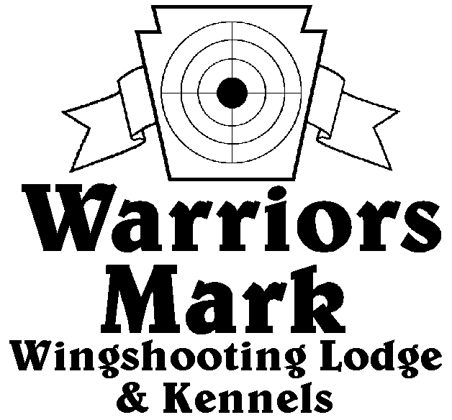
548 Hunt Club Dr. Ginter, PA 16651
814-378-8380 www.warriorsmark.com
RESULTS - The 2017 Chukar Challenge was held at Warriors Mark Wingshooting Lodge. We want to thank all those who participated in the event as well as the many spectators who came to watch. The following are the results of each division and class represented at this event.
Puppy Pointing
NAME DOG BREED SCORE
*Seth Dellinger Trico GSP 203
*Jim Beckenbaugh Grace GSP 182
Dallas Baird Smoke GSP 131

Single Pointing
NAME NAME DOGBREED SCORE
*Brad Minnick Doc P 337
*Kevin Keisel Lyra ES 334
*Brad Minnick Rio P 330
Charles Fashing Chicesaw ES 328
Kevin Keisel Chaos ES 324
Brad Minnick Rio P 320
Dan Blough Rugger GSP 313
Brad Minnick Snap P 304
Todd Hoffman Mez ES 295
David Unger Gizmo GSP 283
Mark Lynch Sally ES 262
Dan Blough Tessa GSP 255
Clay Campbell Rosie B 245
Seth Dillinger River GSP 238
Todd Hoffman Quay B 225
David Unger Merlot GSP 127
Bob Johnson Kate P 120

Team Pointing
NAME PARTNER NAME DOG BREED SCORE
*Charles Fashing Kevin Keisel Chickasaw ES 423
*Seth Dellinger Eric Dellinger River GSP 382
*Bill Brady Isaac Brady Scarlet B 290

Puppy Flushing
NAME DOG BREED SCORE
*Chris Foust Cody Lab 190
*Dusty Derr Willy Lab 178
Jarrod Anderson Mac Lab 155
Jarrod Anderson Mac Lab 151

Single Flushing
NAME DOG BREED SCORE
*Chuck Fashing Choc Lab 342
*Jake Huff Maze GR 336
*Dusty Derr Tripp Lab 331
*Zane Carns Emma Lab 331
Jeff Thomas Kota AC 327
Mike Ott Drake Lab 315
Diane Keisel Sirus Lab 327
Steve Smith Gunner ESS 326
Kevin Keisel Shiva Lab 311
Jeff Thomas Dexter AC 308
Steve Smith Exxie ESS 300
Mike Newton Switch CBR 299
Kendra Carns Emma Lab 281
Barry Anderson Hawk Lab 260
Wally Simpkins Beaudacious Lab 209
Dallas Baird Hope Lab 155
Wally Simpkins Beaudacious Lab 120

Team Flushing
NAME PARTNER NAME DOG BREED SCORE
* Charles Fashing Kevin Keisel Choctaw Lab 461
*Zane Carns Ed Carns Emma Lab 458
*Ray May Greg Schultheis K Lab 439
*Jim Bennett Ray May Remi Lab 427
Jim Bennett Ray May Jock Lab 421
Barry Anderson Jarrod Anderson Jazz Lab 415
Mike Newton Roxanne Newton Switch CBR 411
*Trophy Winners

